DSC & Azure:

Nesting DSC Configurations:

<#NestedConfig.ps1#>

Configuration FileConfig

{

param (

[Parameter(Mandatory=$true)]

[String] $CopyFrom,

[Parameter(Mandatory=$true)]

[String] $CopyTo

)

Import-DscResource -ModuleName PSDesiredStateConfiguration

File FileTest

{

SourcePath = $CopyFrom

DestinationPath = $CopyTo

Ensure = 'Present'

}

}

Configuration NestedFileConfig

{

Node localhost

{

CopyFrom = 'C:\Test\TestFile.txt'

CopyTo = 'C:\Test2'

}

}

Another configuration inside a configuration

Exploring Partial Configurations:

#DSC & Azure

#Partial Configuration

# <#OSConfig.ps1#>

Configuration OSConfig

{

Param (

[Parameter(Mandatory,

HelpMessage="Domain credentials required to add SQL service account to the local Administrators group.")]

[ValidateNotNullOrEmpty()]

[pscredential]$Credential

)

Import-DscResource -ModuleName PSDesiredStateConfiguration

#In case of collaborated development of codes consisting of 2 teams

#To reduce conflicts of codes between the 2 teams

#Partial Configuration allows 2 streams of development for the generation of individual .mof files

#Then when we need to call the configurations to be applied

#We can publish the 2 streams of configurations

#Then we can call for that single unit to be applied onto a local system

Node localhost

{

#Defining an operating standard for hosting a SQL server on a local domain

#with Windows feature .NET framework core

WindowsFeature "NET-Framework-Core"

{

Ensure = "Present"

Name = "NET-Framework-Core"

Source = "\WindowsServer2012R2sxs"

}

#Windows feature compulsory for hosting a web server on local host

WindowsFeature IIS

{

Ensure = 'present'

Name = 'Web-Server'

IncludeAllSubFeature = $true

}

#Active Directory settings

Group LocalAdmins

{

GroupName = 'Administrators'

MembersToInclude = 'earthfarm\sql_service_account',

'earthfarm\sqladmins'

Ensure = 'Present'

Credential = $Credential

}

}

}

#Executing the configuration to generate the .mof file

OSConfig

#Seperate file created by another team

# <#SQLConfig.ps1#>

Configuration SQLConfig

{

param (

[pscredential]$SetupCredential

)

Import-DscResource -Module xSQLServer

Node localhost

PSDSCAllowDomainUser = $true

{

xSqlServerSetup 'SqlServerSetup'

{

DependsOn = "[WindowsFeature]NET-Framework-Core"

SourcePath = '\SqlServer2016'

SetupCredential = $SetupCredential

InstanceName = 'MSSQLSERVER'

Features = 'SQLENGINE,FULLTEXT,RS,AS,IS'

SQLSysAdminAccounts = 'BUILTINADMINISTRATORS'

}

xSqlServerFirewall 'SqlFirewall'

{

DependsOn = '[xSqlServerSetup]SqlServerSetup'

SourcePath = '\SqlServer2016'

InstanceName = 'MSSQLSERVER'

Features = 'SQLENGINE,FULLTEXT,RS,AS,IS'

}

}

}

SQLConfig

Now, we need to check both configurations as a whole

# <#PullServerPartialConfig.ps1#>

# To deploy [PartialConfiguration]OSConfig & [PartialConfiguration]SQLConfig as a whole

[DscLocalConfigurationManager()]

Configuration PartialConfigDemoConfigNames

{

Settings

{

RefreshFrequencyMins = 30;

RefreshMode = "PULL";

ConfigurationMode = "ApplyAndAutocorrect";

AllowModuleOverwrite = $true;

RebootNodeIfNeeded = $true;

ConfigurationModeFrequencyMins = 60;

}

ConfigurationRepositoryWeb Earthfarm-PullSrv

{

ServerURL = 'https://Earthfarm-PullSrv:8080/PSDSCPullServer.svc'

RepositoryKey = 5b41f4e6-5e6d-45f5-8102-f2227468ef38

ConfigurationNames = @("OSConfig", "SQLConfig")

}

#Keyword PartialConfiguration to publish individual .mof files

PartialConfiguration OSConfig

{

Description = "OSConfig"

ConfigurationSource = @("[ConfigurationRepositoryWeb]Earthfarm-PullSrv")

}

PartialConfiguration SQLConfig

{

Description = "SQLConfig"

ConfigurationSource = @("[ConfigurationRepositoryWeb]Earthfarm-PullSrv")

DependsOn = '[PartialConfiguration]OSConfig'

}

}

Creating an Azure VM DSC Configuration:

#Creating an Azure VM DSC Configuration

# <#TestAzureConfig.ps1#>

Configuration TestAzureConfig

{

#A type of Web Server, instead of local host

Node TypeWebServer

{

WindowsFeature IIS

{

Ensure = 'present'

Name = 'Web-Server'

IncludeAllSubFeature = $true

}

File Directory

{

Ensure = 'present'

Type = 'Directory'

DestinationPath = 'C:\inetpub\wwwroot\ErrorLog'

}

}

Node TypeNotWebServer

{

WindowsFeature IIS

{

Ensure = 'absent'

Name = 'Web-Server'

}

}

}

Publish to get .mof & apply to Azure VMs

Publishing an Azure VM DSC Configuration:

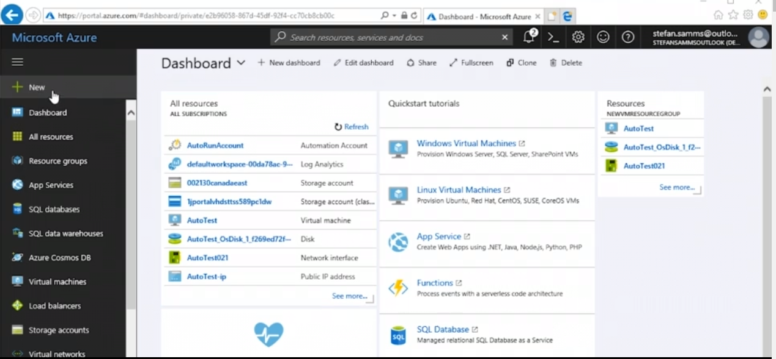In order to apply DSC Configuration,

1. we need an Azure automation account.
2. 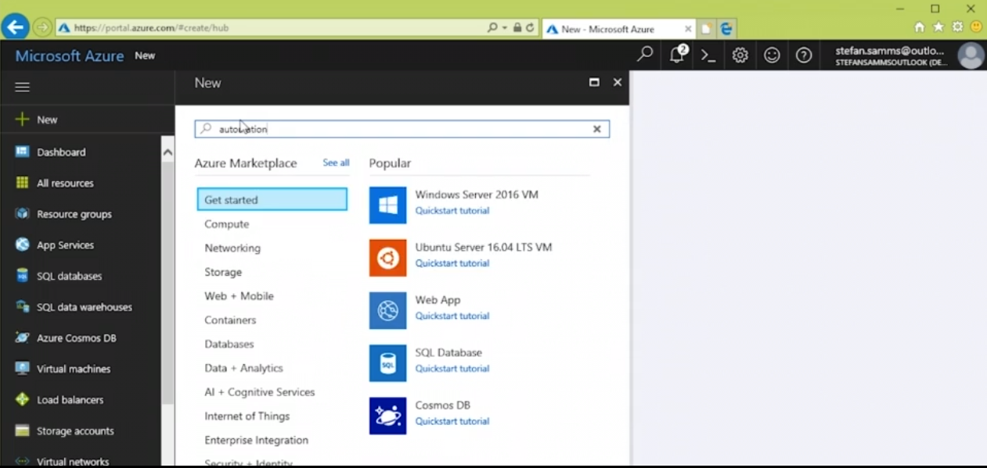 Click + New -> Type Automation
3. 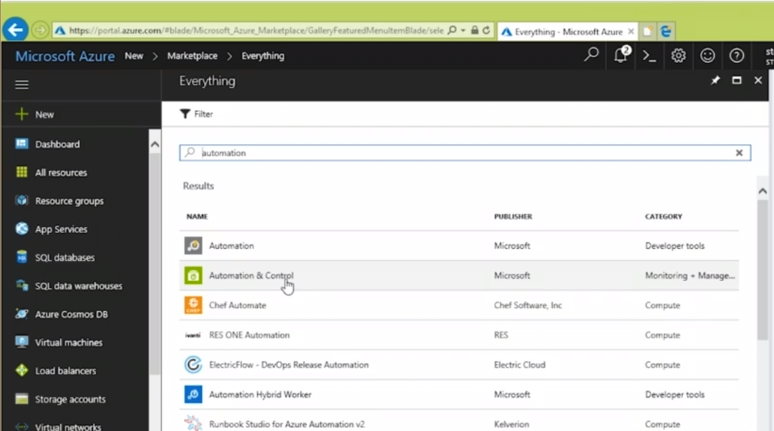Select Automation & Control
4. 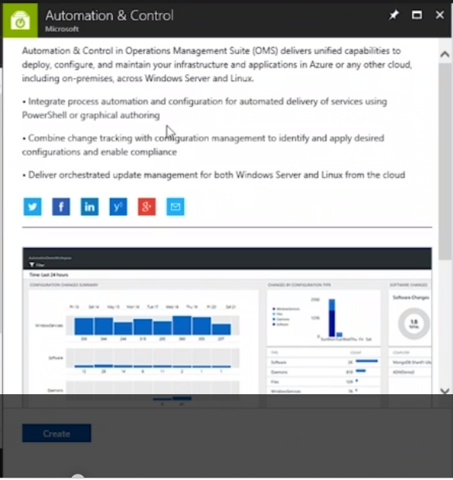Create automation & control profile
5. Go back & click AutoRunAccount

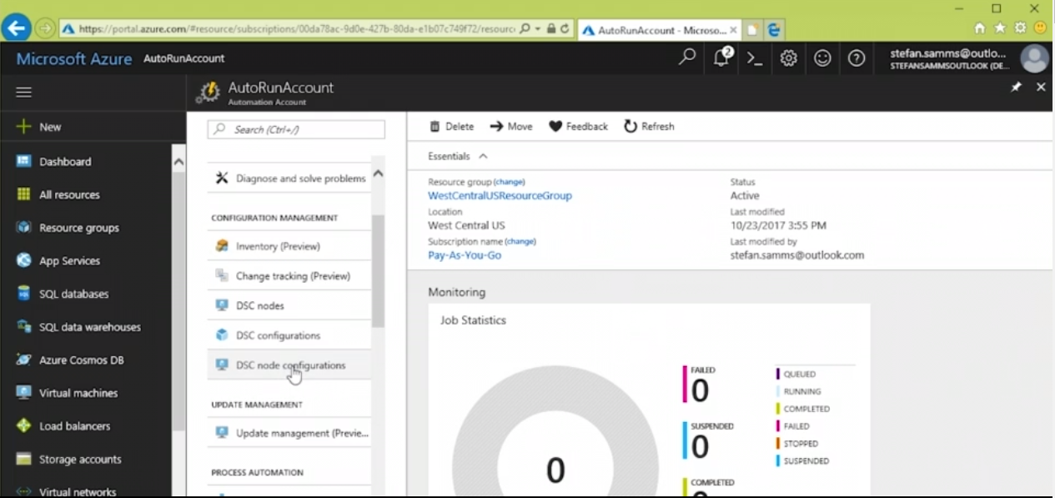

1. Select DSC configuration
2. 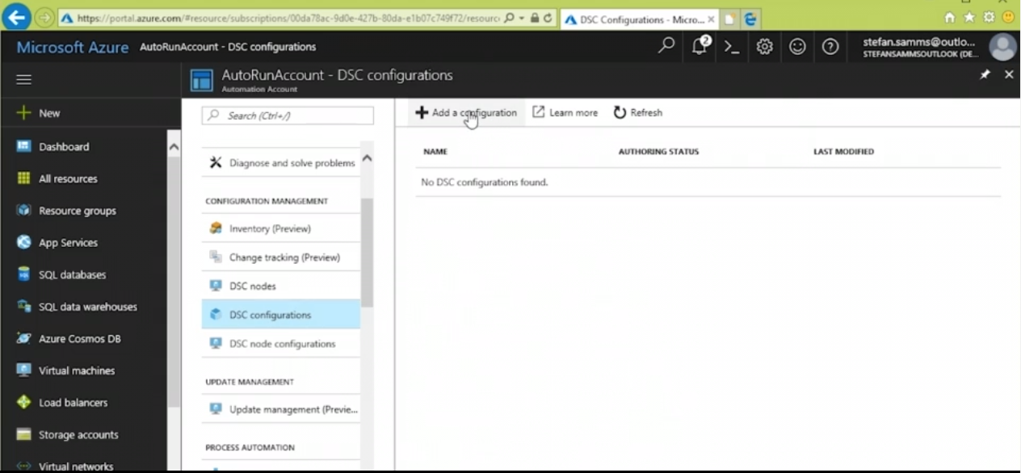Click Add a configuration
3. 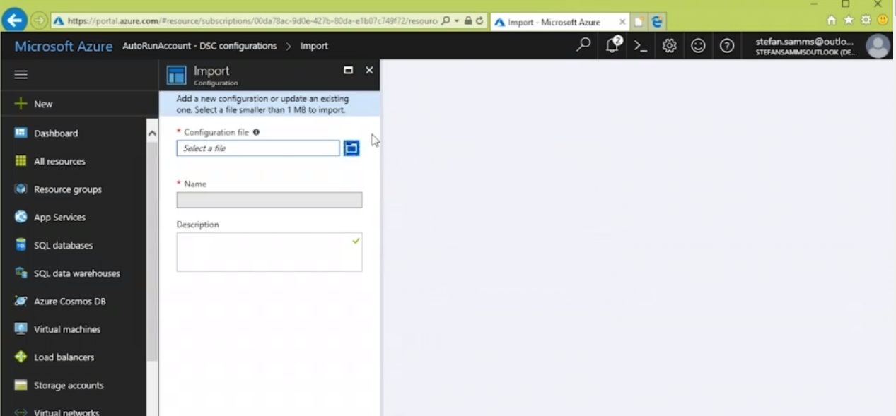Browse & find configuration.ps1 files
4. 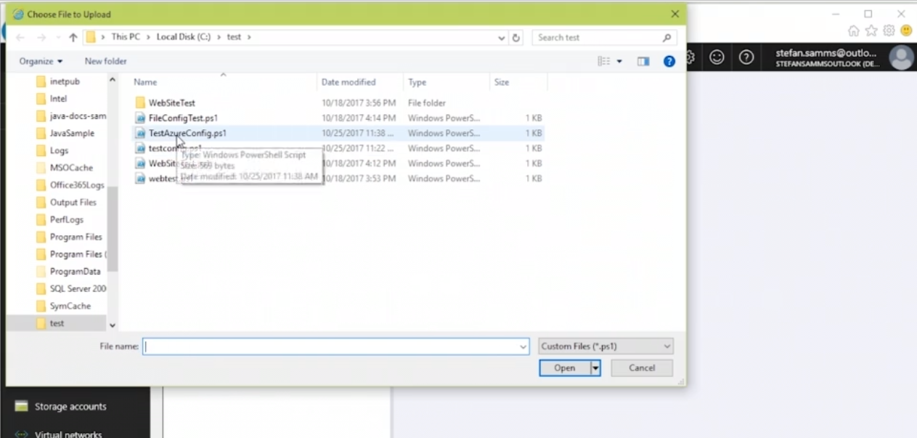Select a configuration .ps1 file
5. 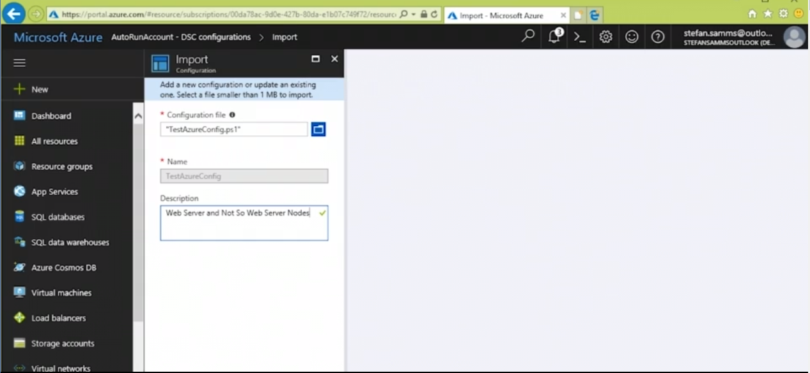Type Description -> OK
6. 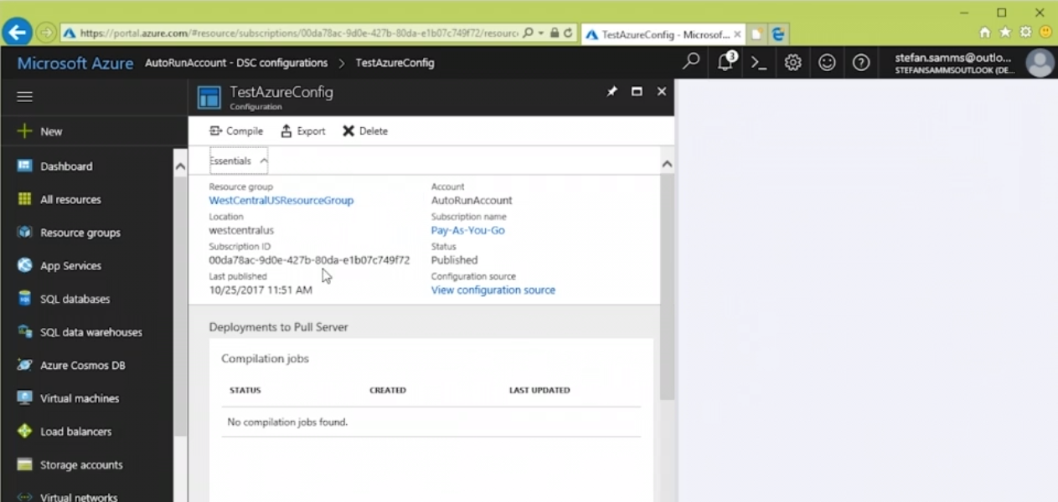Click the Published configuration file -> View configuration source
7. 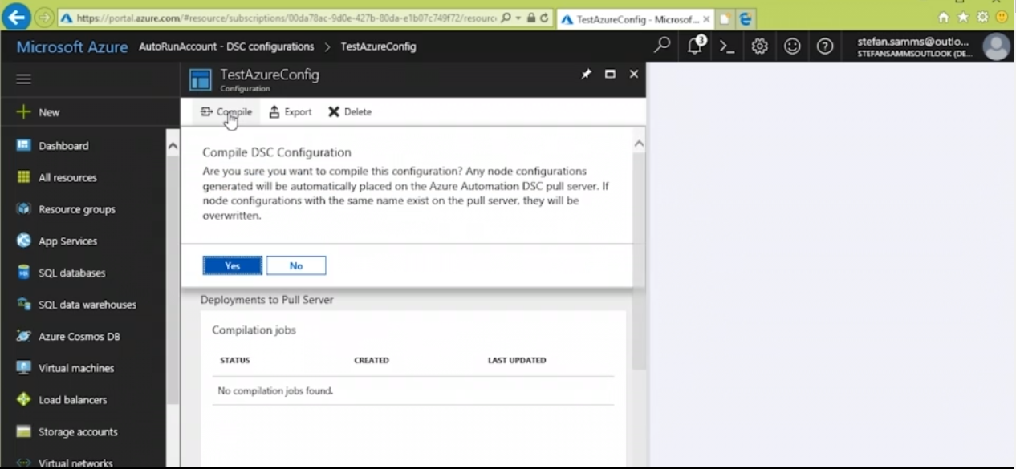Compile the published configuration file
8. 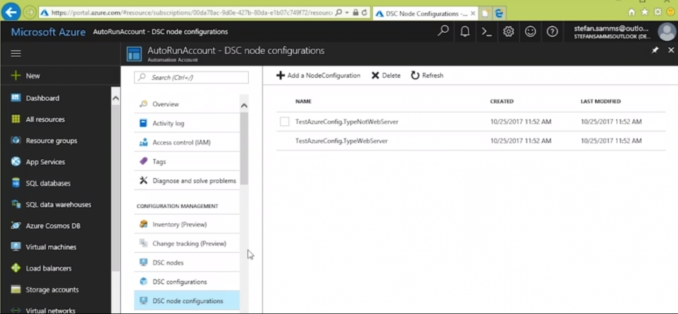Hop to DSC node configuration -> should see 2 configurations
9. Applying an Azure VM DSC Configuration

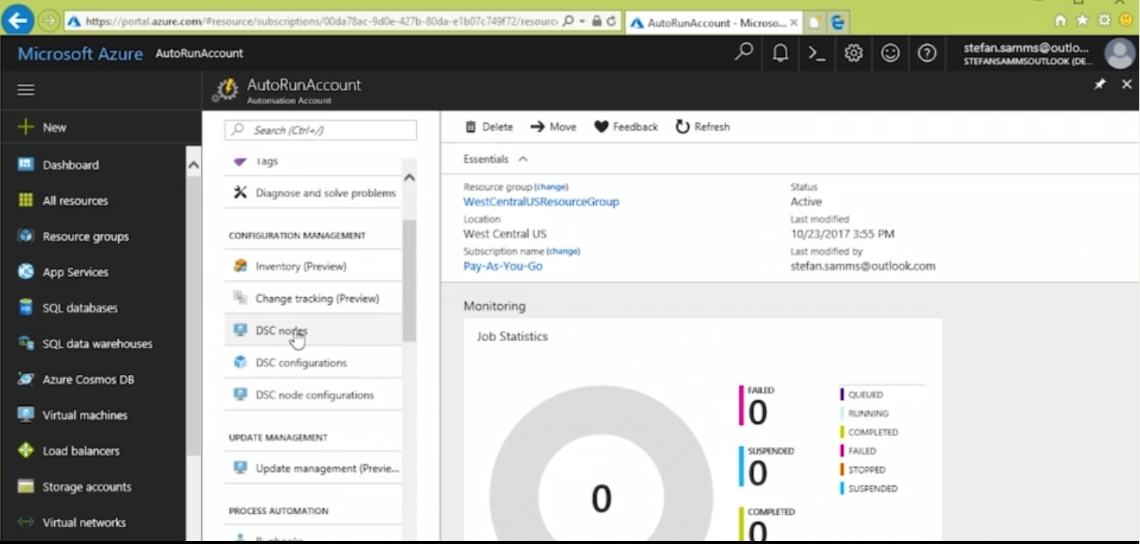Go to AutoRunAccount -> Scroll down -> DSC nodes

1. 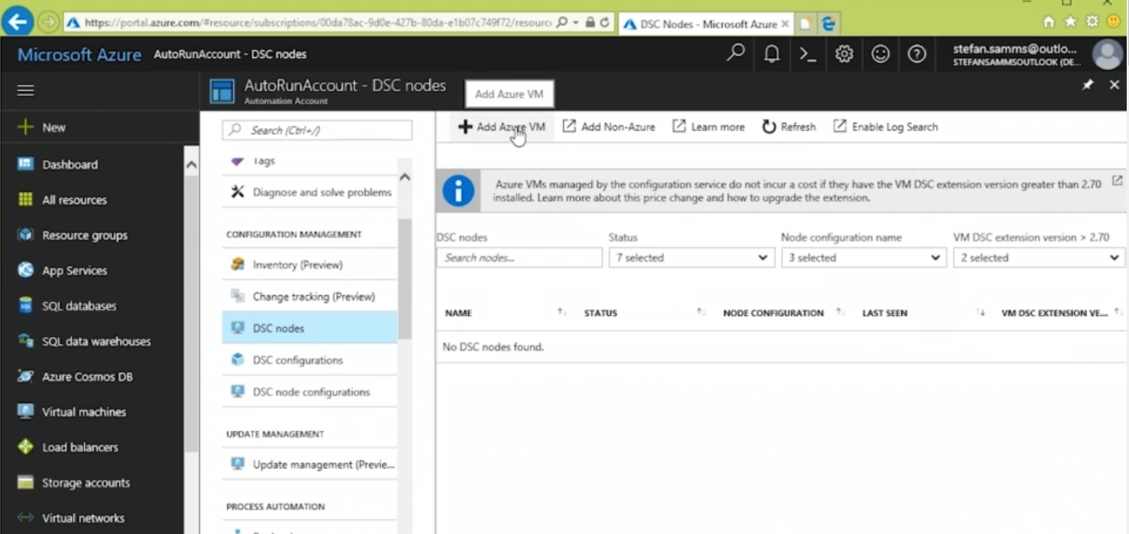Add Azure VM
2. 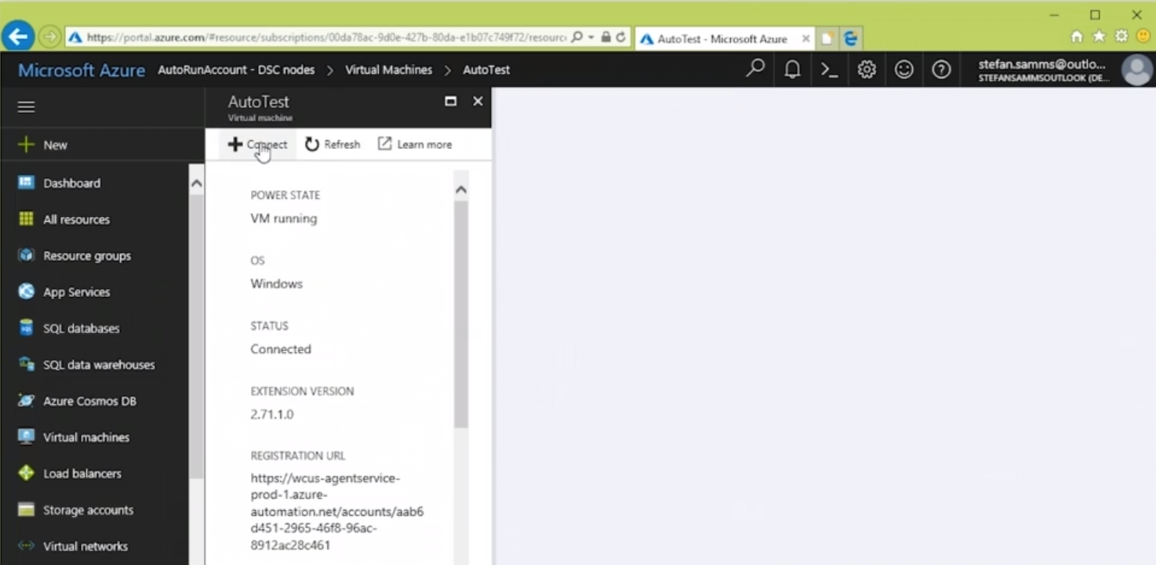Select a VM & Connect
3. 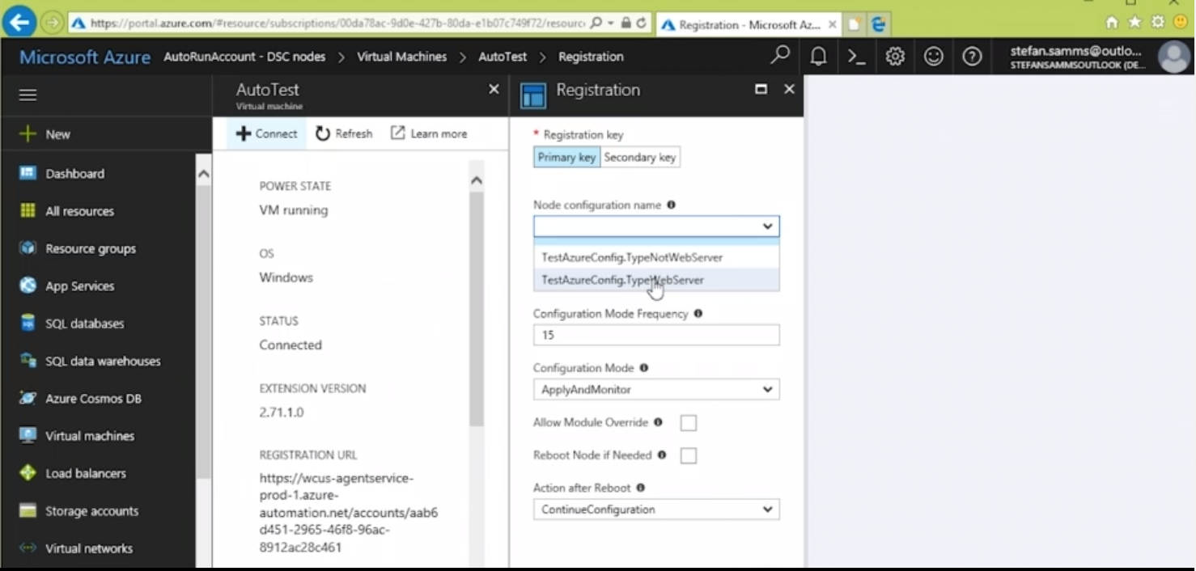Select a configuration
4. 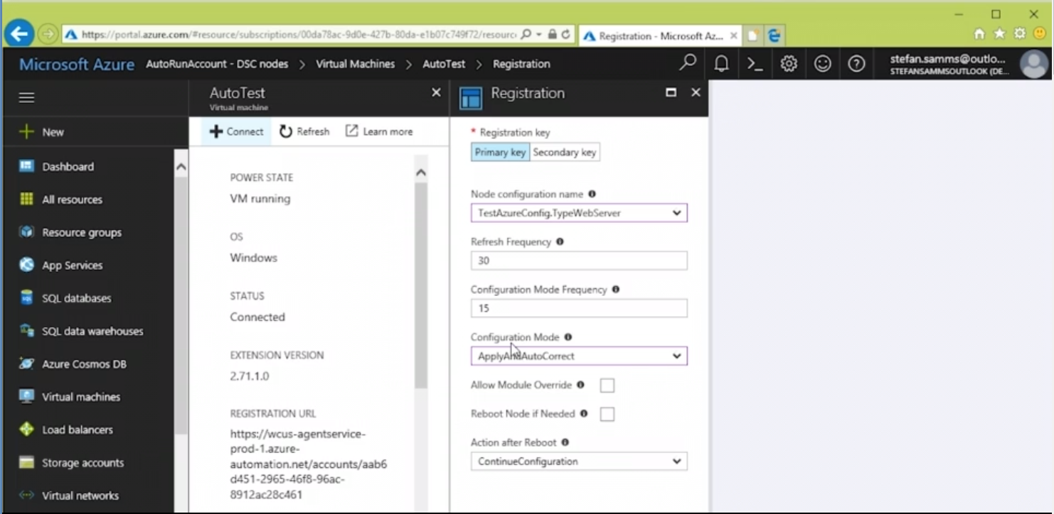Select ApplyAndAutoConnect
5. Check ‘Reboot Node if needed’

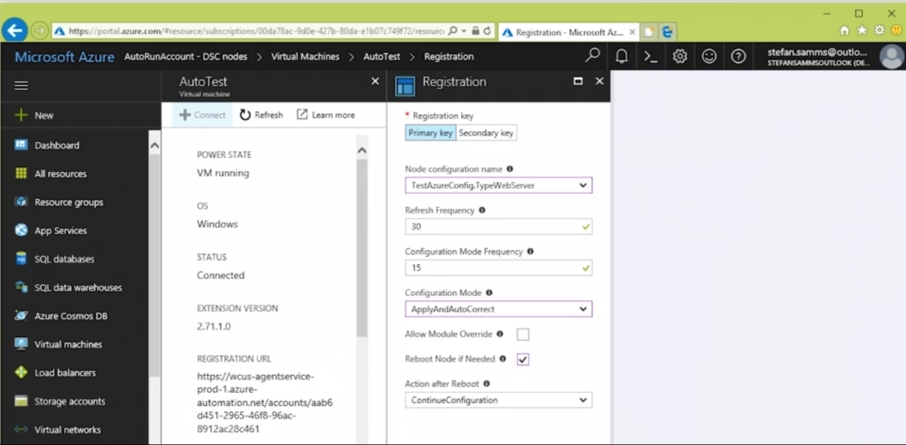Click Connect

Reading Azure DSC Logs:

1. Go to AutoRunAccount

Select DSC nodes underneath

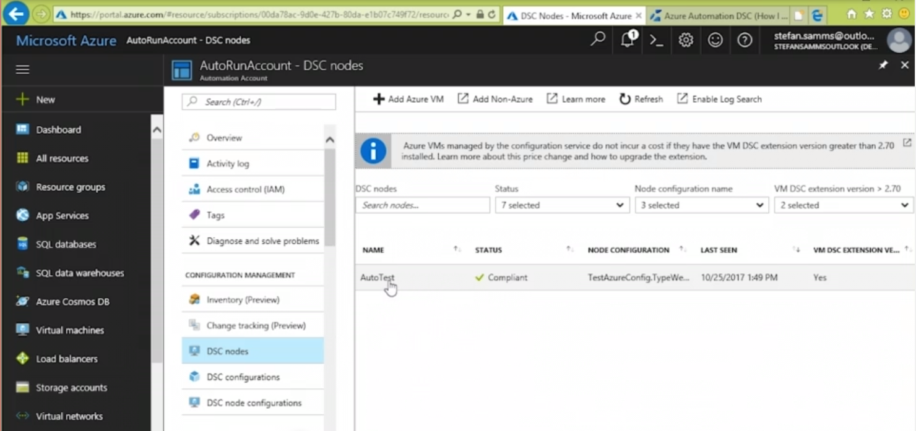Click AutoTest

1. Display all Logs

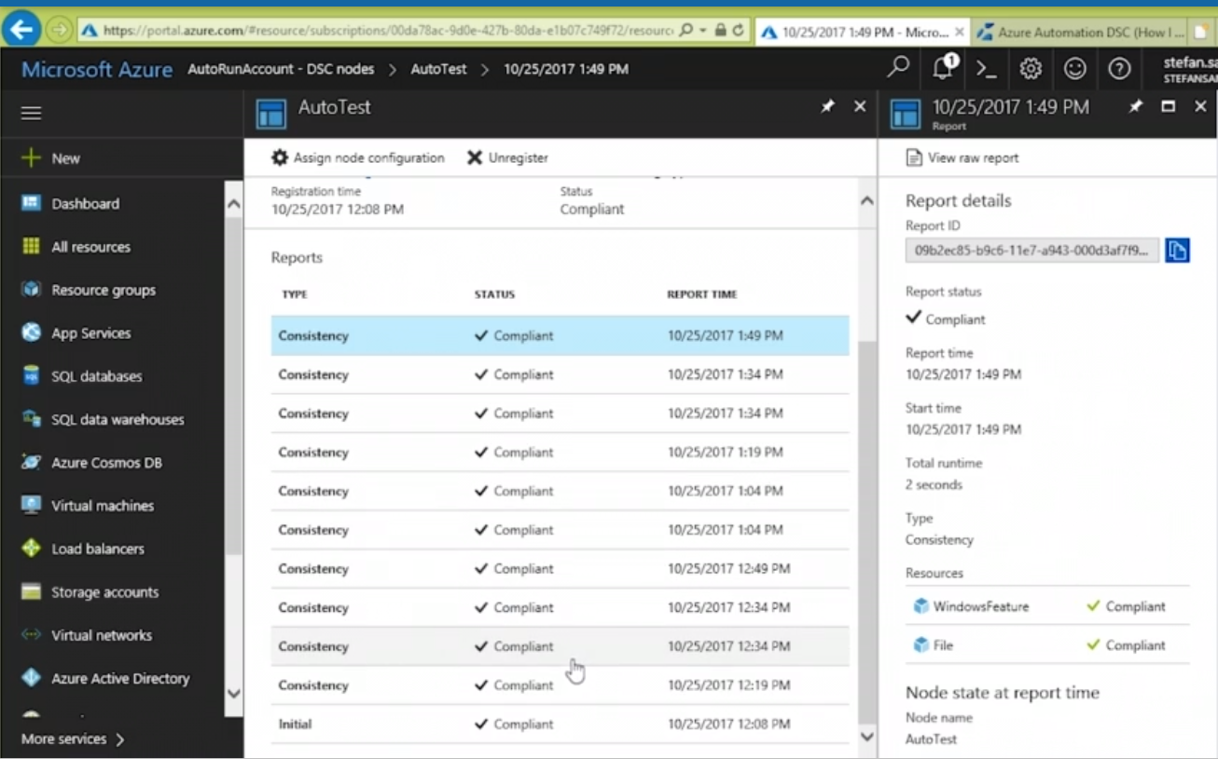Select a Log

1. Check Status whether it’s compliant

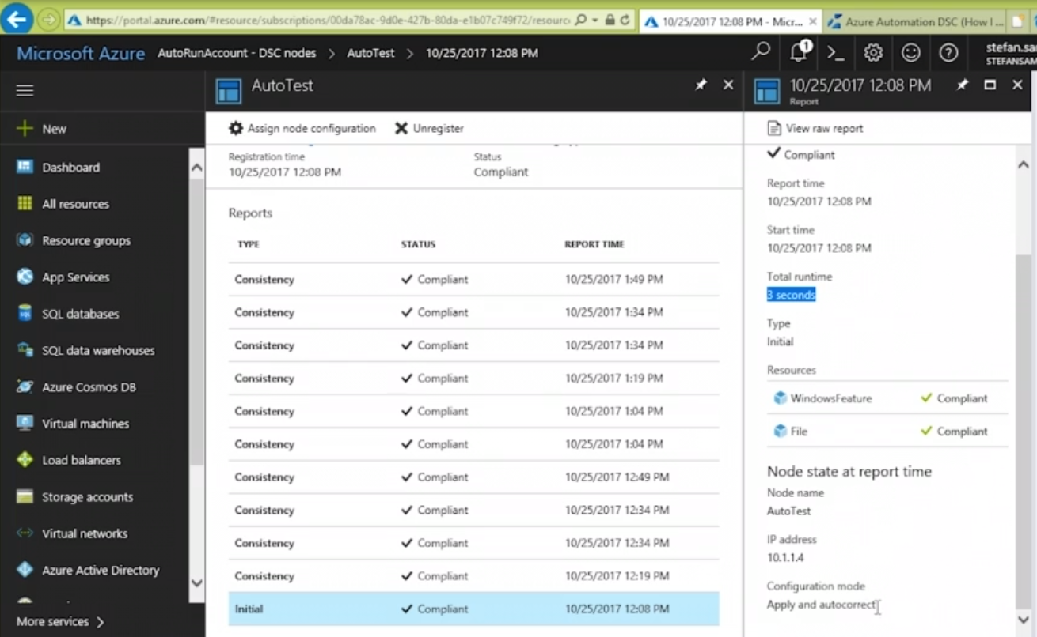Check IP Address & Configuration mode

1. 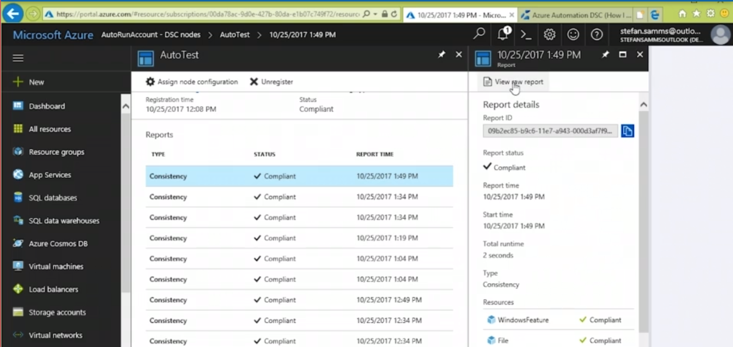Click view raw report to inspect data if needed
2. 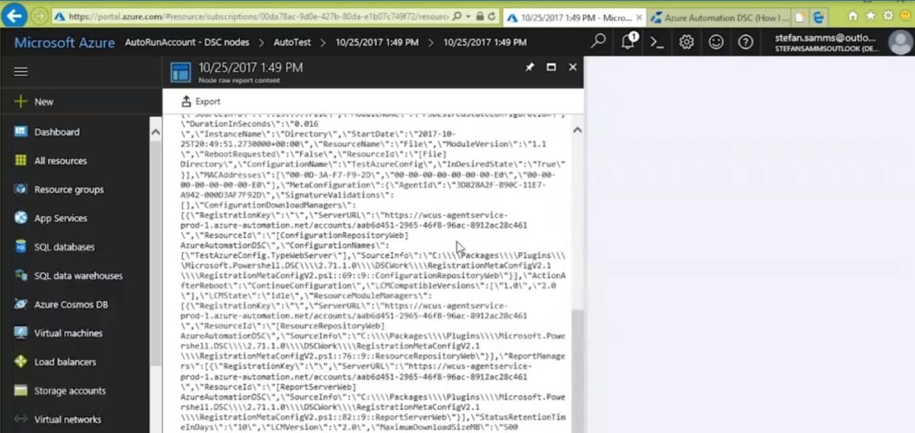Inspecting raw data

Overview of Azure Automation DSC:

What Azure Automation DSC is:

-Azure Automation DSC is an Azure service

-Write, manage and compile DSC configurations

-Import DSC resources

-Assign configurations to target nodes

-Provides a DSC pull server

-Automatic receipt, application, and reporting of configurations

-Provides a Secure Store for credentials

-Based on PowerShell Workflow

-Supports scalability and high availability

-Supports integration into Azure, AWS, Linux, etc.

-Potential uses:

-Purging stale SQL logs

-Live patching of Azure VMs

-Remediation (respond to alerts)

e.g. If specific nodes are not compliant in DSC configurations

can reset the nodes to be compliant again

-Staged deployment of services

Configuring the Hyper-V Role Using DSC:

# <#HyperVConfig.ps1

Configuration HyperVConfig

{

param (

[string]$NodeName = 'localhost'

)

Import-DscResource -ModuleName xHyper-V

node $NodeName {

WindowsFeature 'Hyper-V' {

Ensure = 'Present'

Name = 'Hyper-V'

}

WindowsFeature 'Hyper-V-PowerShell' {

Ensure = 'Present'

Name = 'Hyper-V-Powershell'

}

File VMsDirectory

{

Ensure = 'Present'

Type = 'Directory'

DestinationPath = "$($env:SystemDrive)\VMs"

}

#Create virtual networking for Hyper-V server

xVMSwitch SandboxSwitch {

DependsOn = '[WindowsFeature]Hyper-V'

Name = 'SandboxSwitch'

Ensure = 'Present'

Type = 'Private'

}

xVMSwitch LANSwitch {

DependsOn = '[WindowsFeature]Hyper-V'

Name = 'LANSwitch'

Ensure = 'Present'

Type = 'External'

NetAdapterName = 'Ethernet'

AllowManagementOS = $true

}

}

}

HyperVConfig

Configuring Hyper-V VMs Using DSC:

#<#HyperVBuildVM.ps1#>

Configuration BuildVM

{

param (

[string[]]$NodeName = 'localhost'

)

Import-DscResource -ModuleName xHyper-V

node $NodeName

{

#Build a virtual harddrive for Hyper-V server

xVHD TestServerVHDX

{

Ensure = 'Present'

Name = 'TestServerVHDX'

Path = 'C:\VMs\TestServer.vhdx'

Generation = "vhdx"

}

xVMHyperV TestServer

{

Ensure = 'Present'

DependsOn = '[xVHD]TestServerVHDX'

Name = 'TestServer'

VhdPath = 'C:\VMs\TestServer.vhdx'

SwitchName = 'LANSwitch'

State = 'Running'

Path = 'C:\VMs'

Generation = 'VHDx'

StartupMemory = 4GB

ProcessorCount = 2

}

}

}

#Run this scriptt to generate a .mof file

BuildVM

Bootstrapping LCM Configuration of Hyper-V VMs:

#Embedded DSC configurations for Hyper-V VMs:

#Bootstrapping LCM Configuration of Hyper-V VMs

#<#ConfigForBootstrap.ps1#>

Configuration IISInstall

{

Import-DscResource -ModuleName 'PSDesiredStateConfiguration'

node ('localhost')

{

WindowsFeature IIS

{

Ensure = 'Present'

Name = 'Web-Server'

}

}

}

#Generate a local host .mof file

IISInstall

#<#ConfigForBootstrap_FollowingSteps.ps1#>

#Create a vhd for a windows image

Diskpart

Create vdisk file=C:\VHD\test.vhd maximum=25000 type=expandable

Select vdisk file=C:\VHD\test.vhd

attach vdisk

create partition primary

assign letter=G

format quick FS=NTFS label=VHD

exit

#Apply the windows image to the vhd

#F:\sources\install.wim can be downloaded from Microsoft website

#5 is the image5

#Deploying to G:\ drive

imagex /apply F:\sources\install.wim 5 G:\

#move and rename the compiled localhost.mof to Pending.mof (autodetected filename)

#C:\Test\IISInstall\localhost.mof is generated by <#ConfigForBootstrap.ps1#>

#move localhost.mof to G:\ drive & name as Pending.mof

Move-Item -Path C:\Test\IISInstall\localhost.mof -Destination G:\Windows\System32\Configuration\Pending.mof

#Dismount to remove direct access to the vhd content

Dismount-VHD -Path "C:\VHD\test.vhd"

#Create a VM and mount the existing VHD

$newvm = new-vm -Name "TESTServerVM" -MemoryStartupBytes 2GB -Generation 2 -Switchname "LANSwitch"

add-vmharddiskdrive -vmname $newvm -path "C:\VHD\test.vhd"

#After initial boot-up and operating system installation the system will look to the assigned pull server for config

#More flexible approach to manage DSC config on Hyper-VMs using DSC Local Configuration Manager

#<#ConfigForBootstrap2.ps1#>

#To manage to local configuration manager

#Adopting a Pull Server

[DSCLocalConfigurationManager()]

Configuration PullClientBootstrap

{

Node localhost

{

Settings

{

RefreshMode = 'Pull'

RefreshFrequencyMins = 30

RebootNodeIfNeeded = $true

}

ConfigurationRepositoryWeb Earthfarm-PullSrv

{

ServerURL = 'https://Earthfarm-PullSrv:8080/PSDSCPullServer.svc'

RegistrationKey = '140a952b-b9d6-406b-b416-e0f759c9c0e4'

#Setting the server to find IISInstall located in <#ConfigForBootstrap.ps1#>

ConfigurationNames = @('IISInstall')

}

}

}

#Generate a localhost.meta.mof file

PullClientBootstrap

#<#ConfigForBootstrap2_FollowingSteps.ps1#>

#Create a vhd for a windows image

Diskpart

Create vdisk file=C:\VHD\test.vhd maximum=25000 type=expandable

Select vdisk file=C:\VHD\test.vhd

attach vdisk

Create partition primary

assign letter=G

format quick FS=NTFS label=VHD

exit

#Apply the windows image to the vhd

imagex /apply F:\sources\install.wim 5 G:\

#Move and rename the compiled localhost.mof to MetaConfig.mof (autodetected filename)

#C:\Test\PullClientBootstrap\localhost.meta.mof is generated by IISInstall located in <#ConfigForBootstrap2.ps1#>

Move-Item -Path "C:\Test\PullClientBootstrap\localhost.meta.mof" -Destination "G:\Windows\System32\Configuration\MetaConfig.mof"

#Dismount to remove direct access to the vhd content

Dismount-VHD -Path "C:\VHD\test.vhd"

#Create a VM and mount the existing VHD

$newvm = new-vm -Name "TESTSERVERVM" -MemoryStartupBytes 2GB -Generation 2 -Switchname "LANSwitch"

add-vmharddiskdrive -vmname $newvm -Path "C:\VHD\test.vhd"

#After initial boot-up and operating system installation the system will look to the assigned pull server for config

Bootstrapping LCM Configuration of Hyper-V VMs:

#<#ConfigForBootstrap.ps1#>

Configuration IISInstall

{

Import-DscResource -ModuleName 'PSDesiredStateConfiguration'

node ('localhost')

{

WindowsFeature IIS

{

Ensure = 'Present'

Name = 'Web-Server'

}

}

}

#Generate a local host .mof file

IISInstall

#<#ConfigForBootstrap_FollowingSteps.ps1#>

#Create a vhd for a windows image

Diskpart

Create vdisk file=C:\VHD\test.vhd maximum=25000 type=expandable

Select vdisk file=C:\VHD\test.vhd

attach vdisk

create partition primary

assign letter=G

format quick FS=NTFS label=VHD

exit

#Apply the windows image to the vhd

#F:\sources\install.wim can be downloaded from Microsoft website

#5 is the image5

#Deploying to G:\ drive

imagex /apply F:\sources\install.wim 5 G:\

#move and rename the compiled localhost.mof to Pending.mof (autodetected filename)

#C:\Test\IISInstall\localhost.mof is generated by <#ConfigForBootstrap.ps1#>

#move localhost.mof to G:\ drive & name as Pending.mof

Move-Item -Path C:\Test\IISInstall\localhost.mof -Destination G:\Windows\System32\Configuration\Pending.mof

#Dismount to remove direct access to the vhd content

Dismount-VHD -Path "C:\VHD\test.vhd"

#Create a VM and mount the existing VHD

$newvm = new-vm -Name "TESTServerVM" -MemoryStartupBytes 2GB -Generation 2 -Switchname "LANSwitch"

add-vmharddiskdrive -vmname $newvm -path "C:\VHD\test.vhd"

#After initial boot-up and operating system installation the system will look to the assigned pull server for config

#<#ConfigForBootstrap2.ps1#>

#To manage to local configuration manager

#Adopting a Pull Server

[DSCLocalConfigurationManager()]

Configuration PullClientBootstrap

{

Node localhost

{

Settings

{

RefreshMode = 'Pull'

RefreshFrequencyMins = 30

RebootNodeIfNeeded = $true

}

ConfigurationRepositoryWeb Earthfarm-PullSrv

{

ServerURL = 'https://Earthfarm-PullSrv:8080/PSDSCPullServer.svc'

RegistrationKey = '140a952b-b9d6-406b-b416-e0f759c9c0e4'

#Setting the server to find IISInstall located in <#ConfigForBootstrap.ps1#>

ConfigurationNames = @('IISInstall')

}

}

}

#Generate a localhost.meta.mof file

PullClientBootstrap

#<#ConfigForBootstrap2_FollowingSteps.ps1#>

#Create a vhd for a windows image

Diskpart

Create vdisk file=C:\VHD\test.vhd maximum=25000 type=expandable

Select vdisk file=C:\VHD\test.vhd

attach vdisk

Create partition primary

assign letter=G

format quick FS=NTFS label=VHD

exit

#Apply the windows image to the vhd

imagex /apply F:\sources\install.wim 5 G:\

#Move and rename the compiled localhost.mof to MetaConfig.mof (autodetected filename)

#C:\Test\PullClientBootstrap\localhost.meta.mof is generated by IISInstall located in <#ConfigForBootstrap2.ps1#>

Move-Item -Path "C:\Test\PullClientBootstrap\localhost.meta.mof" -Destination "G:\Windows\System32\Configuration\MetaConfig.mof"

#Dismount to remove direct access to the vhd content

Dismount-VHD -Path "C:\VHD\test.vhd"

#Create a VM and mount the existing VHD

$newvm = new-vm -Name "TESTSERVERVM" -MemoryStartupBytes 2GB -Generation 2 -Switchname "LANSwitch"

add-vmharddiskdrive -vmname $newvm -Path "C:\VHD\test.vhd"

#After initial boot-up and operating system installation the system will look to the assigned pull server for config